**Sequence Diagram for Sell Car**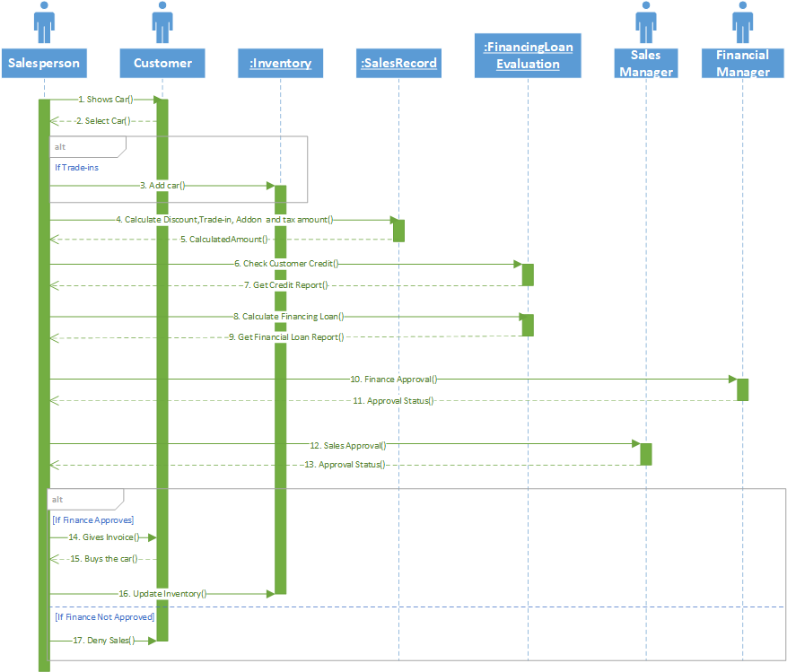

**Communication Diagram for Sell Car**

